**ITCS 1212L**

**Lab Lesson 8**

**Definition of web-services and how web-services work**

**What is a web service?**

The term web service consists of two words: “web” and “service”. If we define this term word by word it implies that it is a service that lives on the web. As we know “Web” is a wide information space in which the resources are connected by internet. In this context the word “Service” refers to an application or a resource which is designed to be used by other applications and software rather than humans.

To define web service in the most simple and basic way, we can say web service is an application that provides application to application communication over the web. In other words the process of making applications talk to each other over the web is simplified by using web services. [5]

Web service enables us to call a program or a procedure over the web. Since web services run over the web, they can call any program on other computers over the world. They can work on local networks as well. [3] Web services are not dependent on any one operating system or programming language. Web services allow us to share the functionality of our developed program over the network.

**Here are some scenarios to explain the use of web services:**

Imagine that you are writing a program that produces stock price quotes in US dollars. One of your customers is in Germany and need the price in Euro. In this case you can call a web service that is located somewhere on the internet or local network to get the current price rate in euro. Figure 1 illustrates this scenario.

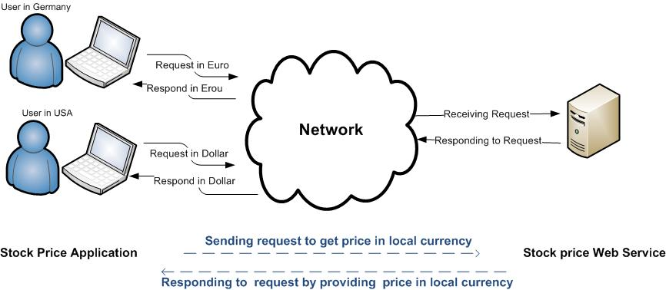

*Figure1. Process of calling stock price web service*

Another example is, suppose you write a purchasing program that gets the user’s credit card’s number to buy something. Once the user enters the credit card’s number into your application, it needs to calls a web service on the bank’s computer to get the approval from the bank immediately and finalize the purchasing process. Figure 2 illustrates this scenario.

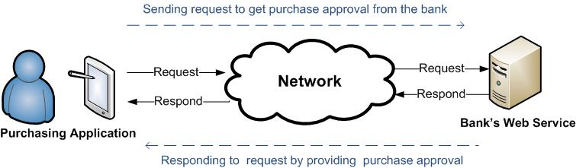

*Figure2. Process of calling bank web service for purchasing purpose*

Or suppose you write a program that shows the weather forecast. Since the users use this application from different parts of the world, the application needs to call a web service which responds to the local user’s request according to their region. Figure 3 illustrates this scenario.

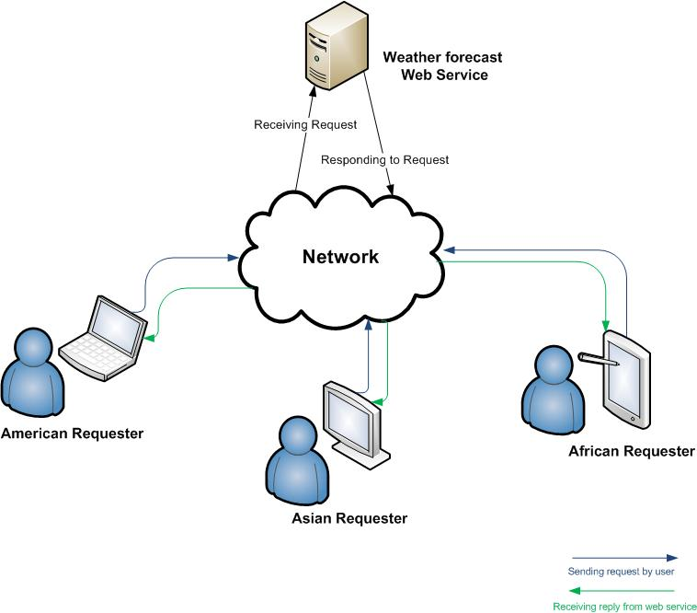

*Figure3. Process of calling weather forecast web service*